* Does have some math – ignore equations – except the one she mentions to remember – no need to derive anything
* Co-factor helps them to perform their tasks efficiently
* Energy term
* Free energy – thermodynamic quantity – driving force for enzyme direction – have limitation – clever way to overcome unfavourable energetics
* Enzyme kinetics – how rates of enzyme can be determined
* Enzymes are proteins – 20% proteins are enzymes – catalysts are prime function – increase rate of reaction without being changed – can participate but has to be regenerated – accelerate equilibrium without changing thermodynamic
* Lower energy barrier – activation energy of transition state – the way enzyme works
* Called agents of metabolic change – coined in 1878
* Cannot catalyst reactions that are energetically unfavourable
* Catalyst that reduces activation energy
* Carbonic acid formation – carbon dissolves in water to cause H2CO3 – reaction super slow – 10 million times faster with enzyme
* Won’t be able to perform tasks without enzyme
* Speed up is normally million to 10^12 with enzymes
* The enzymes perform rate enhancement under mild reaction condition
* All reactions occur under 100 degrees at P = 1 atm, almost neutral pH
* Great specificity in enzymes – both substrates and products
* Enzyme has to be controlled and regulated – allosteric or covalent modifications
* Controlled amount of enzyme by controlling rates of gene expression, transcription, translation
* 6 categories of enzymes
  + Most important is oxidoreductases – oxidation reduction
  + Transferases – transfer functional group - eg. kinase - transfer phosphate from ATP to another molecule
  + Hydrolases – opposite of condensation – adding water to covalent bond
  + Lyases – group elimination to form double bonds
  + Isomerases – transform molecules so that they become substrates
  + Ligases – stick things together – done by using energy from ATP hydrolysis
* Name of enzymes – tell what the enzymes do - eg. glucose-6-phosphatase
  + Ending with “-ase” meaning enzyme
  + Use glulcose-6-phosphate as substrate
  + Phosphatase – remove phosphate – hydrolatic enzyme from the substrate group
* Major classes of enzymes examples
  + alcohol dehydrogenase – oxidoreductases – break down ethanol into acetaldehydes
  + hexokinase – transferase - add phosphate group to glucose for glucose breakdown
  + hydrolases - carbosypeptidase – cut down the last amino acid in peptide chain
  + ligases - pyruvate carboxylase – take pyruvate – add carboxyl group
* Enzymes are very selective – prefer specific substrates – specific stereochemistry – work very well for particular one or two substrates – stereospecificity
* Substrate specificity – chymotrypsin - break down protein by recognising aromatic residues – will cut peptide bond immediately if the next one is not proline – if feed ester – breakdown but not efficient
* Some enzymes need cofactors – can be metal ions or coenzymes – coenzymes have cosubstrates (participate – act as substrate – has to be regenerated) and prosthetic groups (do not change – provide environment)
* The ions and coenzymes have 3D structures
* Vitamins are coenzymes – perform specific reactions
  + Nicotinamide adenine dinucleotide – vitamin B3 – called niacin in free form
  + NAD+ - has nicotinamide, D-Ribose, adenosine – oxidised form has benzene ring
  + NADP+
  + NAD is the participant when we metabolise ethanol to acetaldehyde by ADH – NAD+ becomes NADH and ethanol is oxidised
  + NADH is regenerated by other chemical processes and fed back to the reaction
  + Without NAD+, the enzyme will not function
* Metal ions
  + Ion and cytochrome oxidase
  + Zinc and alcohol dehydrogenase
  + Cobalt and cobalamin – vitamin B12
  + Eg. zinc helping carboxypeptidase A enzyme –carboxypeptidase A takes off the very last residue in a protein – zinc in present of solvent (water) able to hydrolyse the bond and free the N-terminal and COOH group
* Apo and holo enzymes
  + Apoenzyme – inactive without the bound cofactor
  + Holoenzyme – has cofactor bound – active
  + Complexes where substrate is bound – ternary complex
  + Coenzymes which can be chemically changed but need to be regenerated for the enzyme to continue function
* Thermodynamics:
  + Delta G
  + The rate of chemical reaction depends on many factors
  + To know whether the chemical reaction occurs or not – need to go back to thermodynamic
  + Free energy difference between the initial and final state – refer to products and substrates
  + Gibbs free energy – G
  + Delta G is the measure of the change from substrate to product
  + 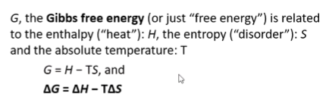
  + Delta G represents a portion of the energy that is required to do useful work at constant temperature and pressure
  + If delta G is negative – product is lower energy than reactant – thermodynamically favourable – exergonic process
  + If delta G is zero – reversible – no extra energy to do work – but can balance the budget – equilibrium process
  + Positive – product higher energy than reactants – difficult as need to pump up reactants to become products – unfavourable – endergonic process
* Transition state – everything is assembled – no reaction – no product – determine the rate of reaction – because the higher the transition state in energy, the more difficult it is to climb the hill
  + The rate depends on order, concentration, temperature, rate constant
  + Free energy has to be negative
  + Initial and final state also go through transition state – additional energy barrier to convert reactants to products if the reaction is reversible
  + The transition state has more free energy – unstable – can switch and form either products or reactants depending on where it is headed
* The change from reactant to product represented on x-axis – free energy on y
  + To form products – have to go through top of hill – transition state
  + Purple is noncatalysed reaction
  + Red reaction is what enzyme does – speed up transition from reactants to products
  + Enzymes bring transitional state to stability and bring it down
  + Once enzyme has brought down the hill, the system checks which side is favourable for spontaneity
  + When product is lower energy than reactant – negative delta G – favourable – will get products
  + Transition state does not go back to form the reactants but form the products
  + 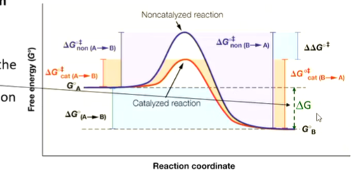
* Enzymes preferentially bind the transition state of the reaction
  + Not as simple as it seems
  + Number of adjustments that need to be made
  + Reactants bind
  + Enzyme-substrate complex (ES) is formed to hold the pieces of the puzzles
  + Transition state which transforms into products
  + Enzymes regenerated
  + Energetics is complicated
  + ES – small local minima
  + Es go through transition state
  + Break down into enzyme and product
  + A number of delta G values throughout the pathway – but we are interested in the delta G of the substrate and the product which drives the reaction
  + 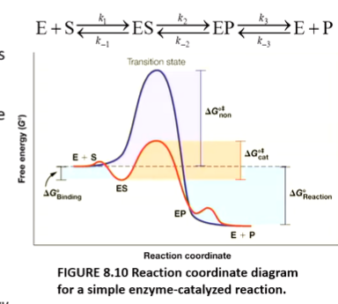



* + Transition state binds best to the enzyme has greatest affinity to the enzyme and complimentary in terms of shapes and electrostatics to the transition state
  + Transition state analogues are often used as inhibitors – extension putting methyl etc – inhibitors in biotech industry and drug designs
* Enzyme inhibitors are used as drugs
  + Real drug molecule
  + The three drugs on slides – Work on HIV protease
  + 1 prevent transcription
  + 2 prevent virus from replicating
  + Protease – 3 preventing it from breaking the cell wall
* Transition state analogues as enzyme inhibitors
  + L-proline forming D-proline in bacterium
  + Proline racemase is the enzyme
  + Need to go through planar transition state in order to change the configuration
  + Pyrrole… and delta… mimic the transition state and stop the bacteria from generating D-proline
* General chemical reaction
  + Most biochemical reactions are reversible reactions
  + Reactants – initial thermodynamics
  + A and B are reactants
  + C and D are products
  + Compare energy on the right side to the left
  + Apply constant temperature and pressure
  + Delta G = 0 -> at equilibrium
  + Balance between amount of products and reactants – constant concentration – equilibrium constant controls this
  + Delta G negative -> get products -> forward reaction occurs spontaneously
  + If positive -> reactants would accumulate -> no forward reaction
  + If delta g is large – only one direction predominates
  + Equilibrium constant is the product of concentration of products divided by reactants
  + Delta g for such reaction can be calculated if we know products and reactants: delta G = products – constants
  + 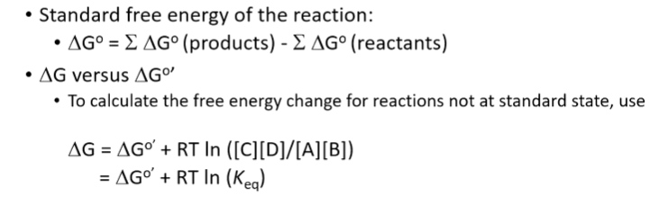
  + ln is the natural log – not log base 10
  + Fine line of -11.2 Kj/mole – enough to push equilibrium to one direction
  + 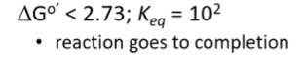
* Biological systems need energy to perform work –
  + Mechanical work - flagella rotation, muscular work, concentration
  + Concentration and electrical work – moving charges through, osmotic changes, etc
  + Synthetic work – changes to chemical bonds – how we cut food up and reassemble them
  + Energy comes from hydrolysis of high energy phosphate bonds (ATP, ADP) and reduced conenzymes (NADH etc)
* To perform energetically unfavourable work (positive delta G)
  + Add 1 phosphate group to glucose to make glucose-6-phosphate
  + Hydrolyse ATP - producing ADP and release a lot of energy
  + Overall energy delta G negative
  + That’s how we get energy from sugar
* Substrates can form complex with enzymes – ES complex breaks down – resulting in E and P
  + Energy of S and P are the same with and without enzymes
  + Enzymes cannot change the delta G but can change the height of the transition state
* Rate of reaction
  + How much P froms from S
  + Rate is represented as v
  + How much product we generate per second
  + V is not a constant number
  + V vs concentration:
    - With enzyme, get hyperbolic curve with a vmax
    - Without enzyme, get straight line
* Amount of substrate decreases and P increases as the reaction goes
* Steady state of ES
* E gets chewed up, regenerated and go back to the reaction
* We only need small quantity of E because it quickly forms ES
* E is usually not free – mostly ES
* V is usually when we have constant ES concentration
* Michaelis-Menten equation
* 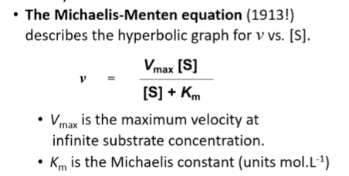
* When v – vmax/2, where it will be perpendicular to S, Km
* 1/v and 1/S – make the curve straight instead of hyperbolic
* 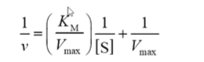
* When km = [S]; v = vmax/2
* Units of Km is mol/L – inversely related to affinity of S for E
  + If small Km – need only a little susbstrate
* Catalic constant Kcat = vmax/[E]
* Kcat is the internal rate – how fast we can use this enzyme – measure the time a given site can turn S into P per second
* Kcat = vmax / [E]
* Kcat/Km measure enzyme efficiency – enzyme specificity constant – determine best S for E with low S
* Km is unique for each ES – low Km is good enzyme
* Large Kcat means large amount of P is being formed